Saiquan Jamison

CTEC 298

October 17, 2019

Dr.Bemley

STACKED BAR GRAPH

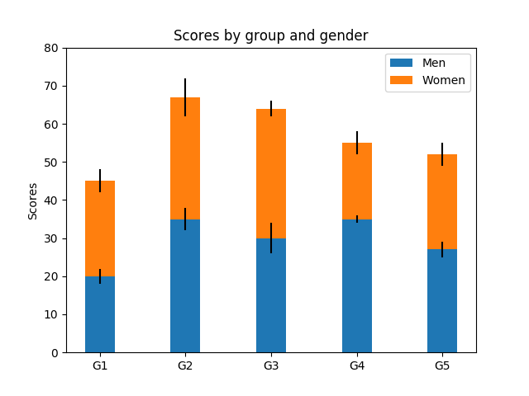

CODE:

import numpy as np

import matplotlib.pyplot as plt

N = 5

menMeans = (20, 35, 30, 35, 27)

womenMeans = (25, 32, 34, 20, 25)

menStd = (2, 3, 4, 1, 2)

womenStd = (3, 5, 2, 3, 3)

ind = np.arange(N) # the x locations for the groups

width = 0.35 # the width of the bars: can also be len(x) sequence

p1 = plt.bar(ind, menMeans, width, yerr=menStd)

p2 = plt.bar(ind, womenMeans, width,

bottom=menMeans, yerr=womenStd)

plt.ylabel('Scores')

plt.title('Scores by group and gender')

plt.xticks(ind, ('G1', 'G2', 'G3', 'G4', 'G5'))

plt.yticks(np.arange(0, 81, 10))

plt.legend((p1[0], p2[0]), ('Men', 'Women'))

plt.show()

BAR GRAPH

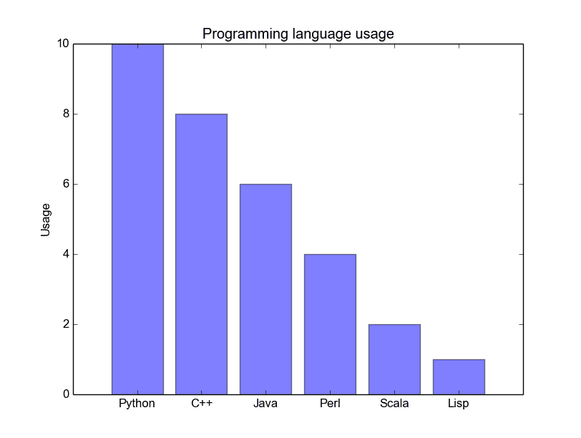

CODE:

import matplotlib.pyplot as plt; plt.rcdefaults()  
import numpy as np  
import matplotlib.pyplot as plt  
  
objects = ('Python', 'C++', 'Java', 'Perl', 'Scala', 'Lisp')  
y_pos = np.arange(len(objects))  
performance = [10,8,6,4,2,1]  
  
plt.bar(y_pos, performance, align='center', alpha=0.5)  
plt.xticks(y_pos, objects)  
plt.ylabel('Usage')  
plt.title('Programming language usage')  
  
plt.show()

HISTOGRAM

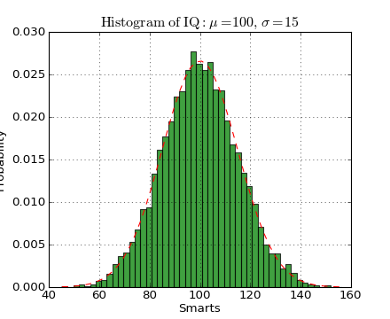

import numpy as np

import matplotlib.mlab as mlab

import matplotlib.pyplot as plt

mu, sigma = 100, 15

x = mu + sigma*np.random.randn(10000)

# the histogram of the data

n, bins, patches = plt.hist(x, 50, normed=1, facecolor='green', alpha=0.75)

# add a 'best fit' line

y = mlab.normpdf( bins, mu, sigma)

l = plt.plot(bins, y, 'r--', linewidth=1)

plt.xlabel('Smarts')

plt.ylabel('Probability')

plt.title(r'$\mathrm{Histogram\ of\ IQ:}\ \mu=100,\ \sigma=15$')

plt.axis([40, 160, 0, 0.03])

plt.grid(True)

plt.show()

SCATTER PLOT

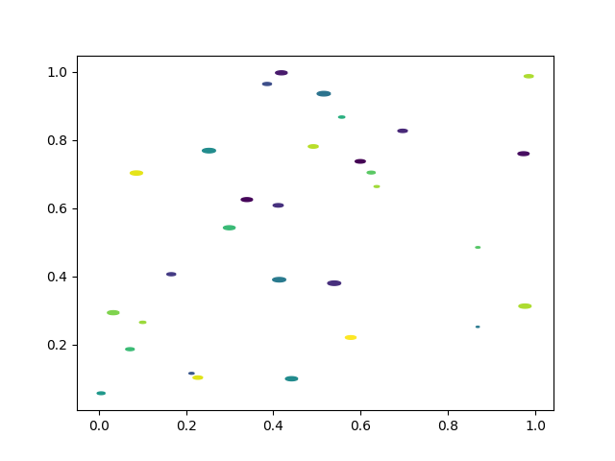

import matplotlib.pyplot as plt

import numpy as np

rx, ry = 3., 1.

area = rx * ry * np.pi

theta = np.arange(0, 2 * np.pi + 0.01, 0.1)

verts = np.column_stack([rx / area * np.cos(theta), ry / area * np.sin(theta)])

x, y, s, c = np.random.rand(4, 30)

s *= 10**2.

fig, ax = plt.subplots()

ax.scatter(x, y, s, c, marker=verts)

plt.show()

PIE CHART

import matplotlib.pyplot as plt

labels = 'White', 'Black', 'Asian', 'Hispanic', ‘Other Races’

sizes = [1, 16, 5, 11, 67]

explode = (0, 0, 0, 0)

fig1, ax1 = plt.subplots()

ax1.pie(sizes, explode=explode, labels=labels, autopct='%1.1f%%',

shadow=True, startangle=90)

ax1.axis('equal')

plt.show()

MULTIPLOT

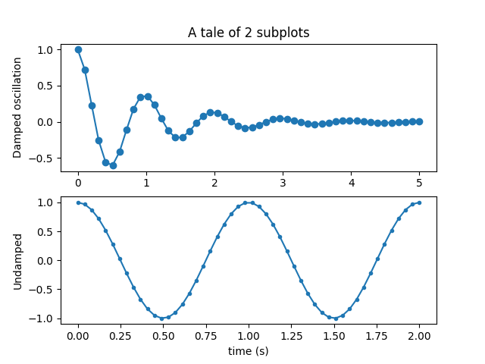

import numpy as np

import matplotlib.pyplot as plt

x1 = np.linspace(0.0, 5.0)

x2 = np.linspace(0.0, 2.0)

y1 = np.cos(2 * np.pi * x1) * np.exp(-x1)

y2 = np.cos(2 * np.pi * x2)

plt.subplot(2, 1, 1)

plt.plot(x1, y1, 'o-')

plt.title('A tale of 2 subplots')

plt.ylabel('Damped oscillation')

plt.subplot(2, 1, 2)

plt.plot(x2, y2, '.-')

plt.xlabel('time (s)')

plt.ylabel('Undamped')

plt.show()